Activity: Research on (sklearn)

Name: Marmol, John Martin T.
Course: Bayesian Statistics
Date: March 14, 2026

What is Scikit-learn (sklearn)?
Scikit-learn is an open-source machine learning library that supports supervised and unsupervised learning. It also provides various tools for model fitting, data preprocessing, model selection, model evaluation, and many other utilities.

Main Features of Scikit-learn:
- Fitting and predicting: estimator basics, Scikit-learn provides dozens of built-in machine learning algorithms and models, called estimators. Each estimator can be fitted to some data using its fit method.
- Transformers and pre-processors, machine learning workflows are often composed of different parts. A typical pipeline consists of a pre-processing step that transforms or imputes the data, and a final predictor that predicts target values. In scikit-learn, pre-processors and transformers follow the same API as the estimator objects (they actually all inherit from the same BaseEstimator class). The transformer objects don’t have a predict method but rather a transform method that outputs a newly transformed sample matrix.
- Pipelines: chaining pre-processors and estimators, transformers and estimators (predictors) can be combined together into a single unifying object: a Pipeline. The pipeline offers the same API as a regular estimator: it can be fitted and used for prediction with fit and predict.
- Model evaluation, fitting a model to some data does not entail that it will predict well on unseen data. This needs to be directly evaluated. We have just seen the train_test_split helper that splits a dataset into train and test sets, but scikit-learn provides many other tools for model evaluation, in particular for cross-validation.
- Automatic parameter searches, all estimators have parameters (often called hyper-parameters in the literature) that can be tuned. The generalization power of an estimator often critically depends on a few parameters. Scikit-learn provides tools to automatically find the best parameter combinations (via cross-validation).

Available Algorithms:
- Classification - Identifying which category an object belongs to.
- Algorithms: Gradient boosting, nearest neighbors, random forest, logistic regression, etc.
- Regression - predicting a continuous-valued attribute associated with an object.
- Algorithms: Gradient boosting, nearest neighbors, random forest, ridge, etc.
- Clustering - automatic grouping of similar objects into sets.
- Algorithms: k-Means, HDBSCAN, hierarchical clustering, etc.
- Dimensionality Reduction - reducing the number of random variables to consider.
- Algorithms: PCA, feature selection, non-negative matrix factorization, etc.
- Model Selection - comparing, validating and choosing parameters and models.
- Algorithms: Grid search, cross validation, metrics, etc.
- Preprocessing - feature extraction and normalization.
- Algorithms: Preprocessing, feature extraction, etc.

How to Install Scikit-learn?
Since I am using Windows, I will show the instructions on how to install scikit-learn in Windows using pip and Anaconda.

Install using pip:
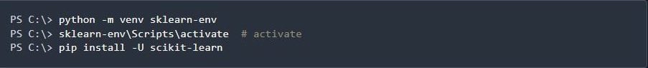
Install the 64-bit version of Python 3, for instance from the official website. Now create a virtual environment (venv) and install scikit-learn. Note that the virtual environment is optional but strongly recommended, in order to avoid potential conflicts with other packages.

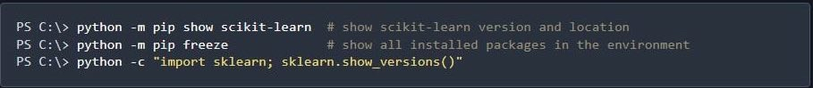
In order to check your installation, you can use:
_____________________________________________________________________________________

Install using Anaconda:
Install conda using the conda-forge installers (no administrator permission required). Then run:
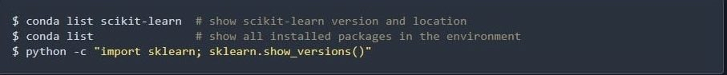
In order to check your installation, you can use:

Reference:
https://scikit-learn.org/stable/

